# Join the APT Technical Committee on Modern Heritage

# for the 2020 Virtual Conference Modernism Mixer!

# October 8, 2020

# 6:00–7:30 p.m. MDT

***Dress:*** *vintage modern cocktail attire; libations encouraged (not required)*

Program

* ***Welcome*** *(Kelly Sutherlin McLeod and Caroline Alderson, TC-MH Co-Chairs)*

*Meet committee leaders and founders, and representatives of affiliated organizations working with modern heritage, and learn about committee initiatives.*

* ***Quiz: Name that Icon! (****David West, emcee)*

*Compete to identify icons of modernism worldwide!*

* ***Author Recognition: Recent Works***

*Learn about some new publications on modern heritage subjects by APT members.*

* ***APT 2020 Student Scholars and Modernism***

*Meet APT 2020 student scholars presenting on modern heritage topics.*

* ***Modern Cocktails Contest***

*Share your favorite modern cocktail—and modern attire and accessories (optional)—and compete for the best vintage cocktail (recipe and presentation)!*

* ***Closing: Reflections on Modern Heritage Today***

*Consider the position of modern heritage today, including resources of the recent past and the heritage of the future.*

***RSVP via e-mail to caroline.alderson@gsa.gov and MSandoval@wje.com.***

***A Zoom invitation to the Modernism Mixer will be sent upon registration!***

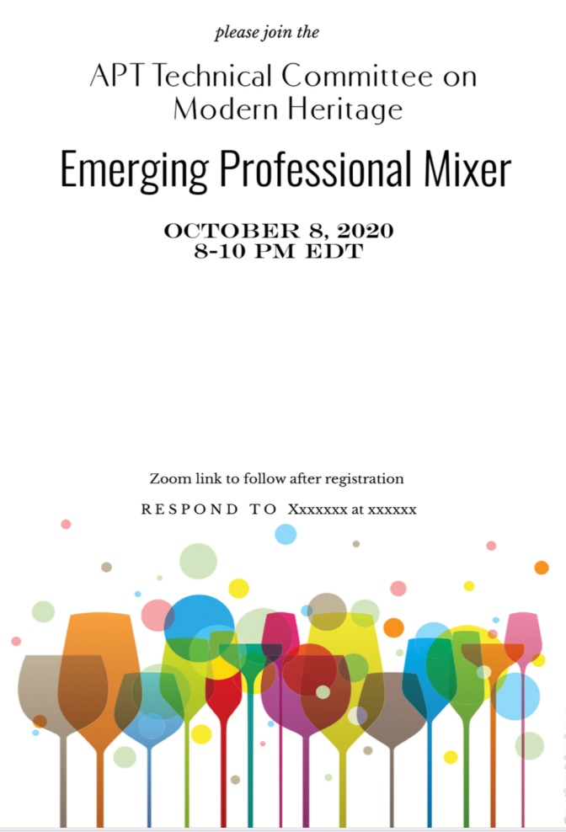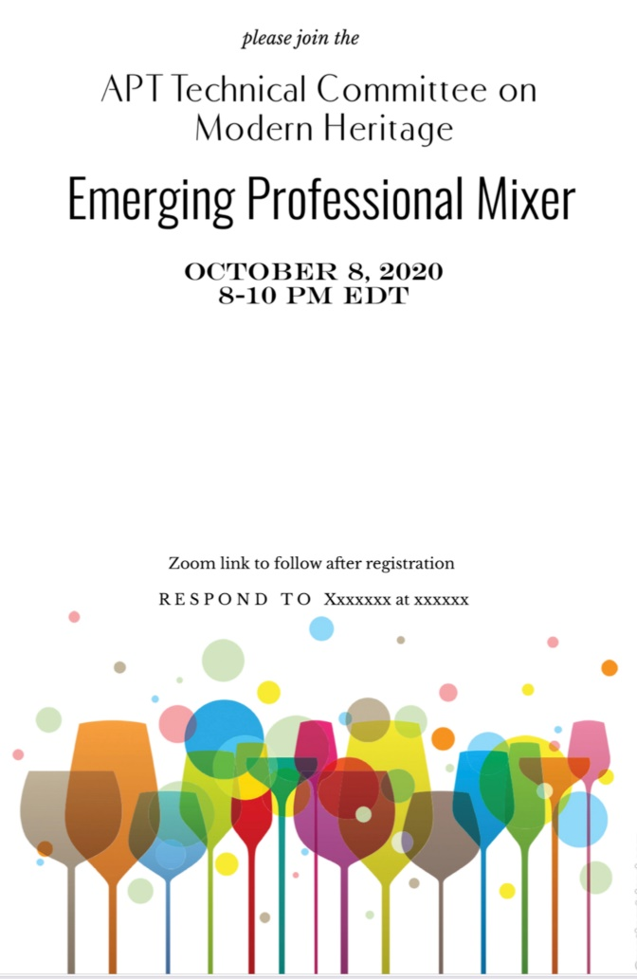

***See you at the next TC-MH monthly meeting, Thursday, November 5, 2020, 2:00 p.m. MDT!***

***Join the TC-MH! E-mail caroline.alderson@gsa.gov.***

***See www.apti.org/modern-heritage for more information.***